Step-by-step instructions for the applicant

- Open the link https://et.hse.ru/
- To log in use the username and password sent to your email in advance. Enter them into the fields shown in the picture and click "Login" .

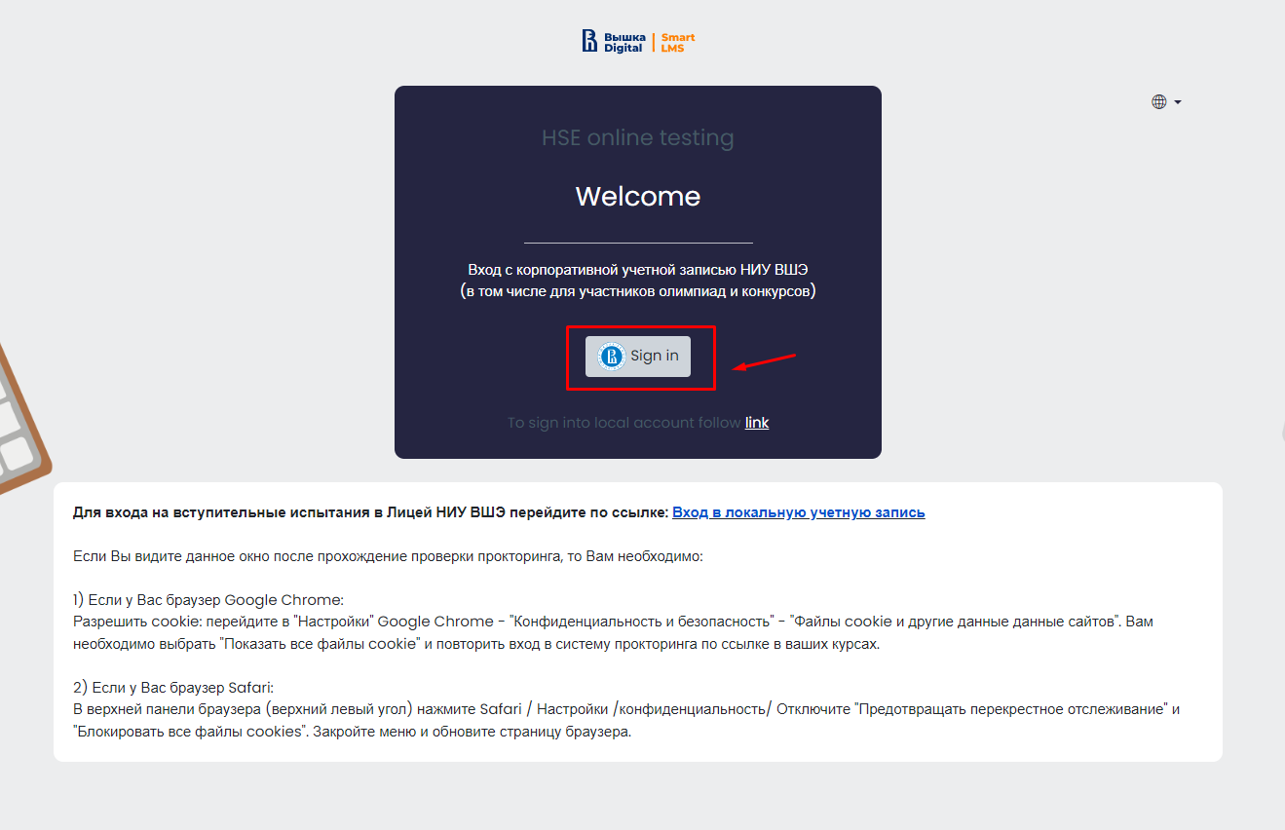

- In the window that opens, go to the “Exams”
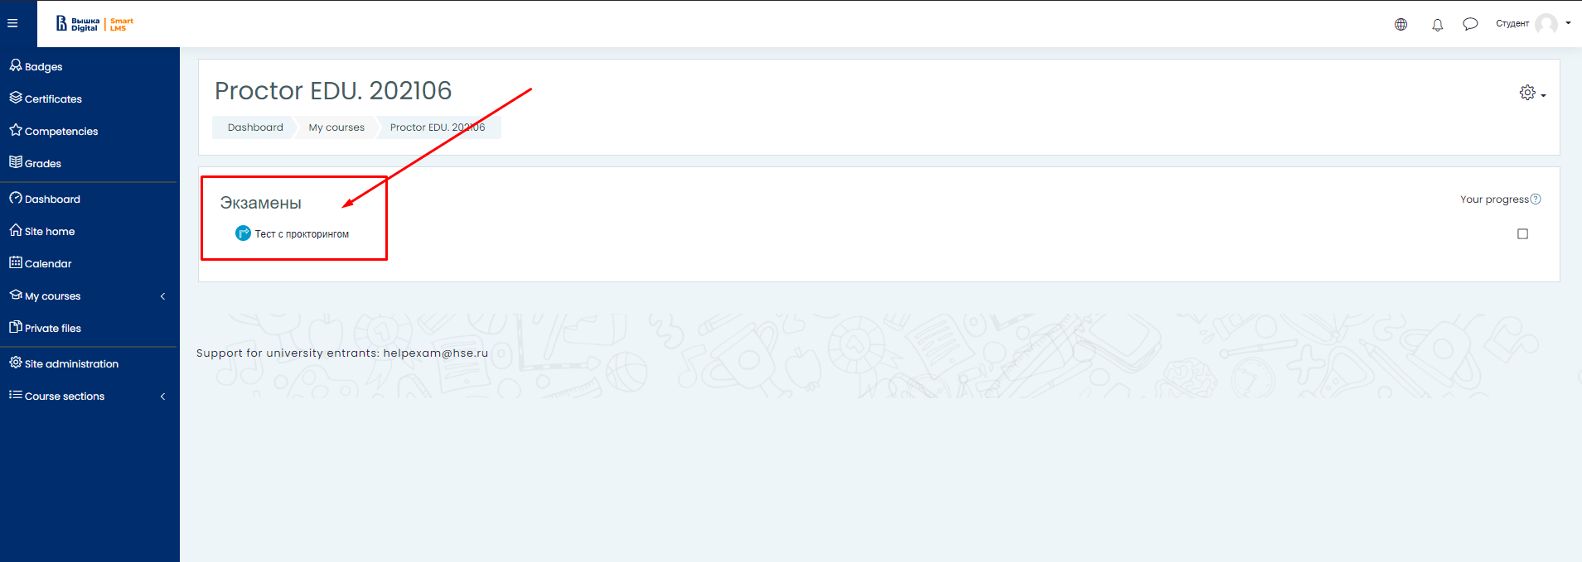
- To start an exam with proctoring read the rules and give your consent to the conditions of the exam
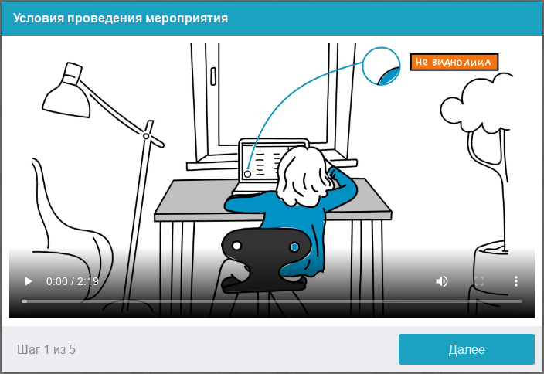
The system automatically sets an assessment of the level of confidence in the exam results, which depends on the factors described below. Compliance with the following guidelines throughout your session will help you get the most credibility score in your exam results:
you consent to audio and video recording and subsequent storage of the entire exam;
the webcam must be installed strictly in front of the face, it is not allowed to install the camera from the side;
the head must completely fit into the frame, partial or complete vanishing from the camera's coverage area is not allowed;
the face must be in the center of the webcam's coverage area and occupy at least 10% of the space captured by the camera throughout the session;
the face should be evenly lit, the light source should not be directed towards the camera or illuminate only one half of the face;
hair, clothing, hands or anything else should not cover the face area;
you are not allowed to wear sunglasses, you can only use glasses with clear lenses;
there should be no other people in the room;
it is forbidden to leave your workplace during the exam;
there should be no voices or noise in the background, the exam has to be taken in complete silence;
passing the exam must be carried out in a browser, the window of which must be maximized to full screen. You are strictly prohibited to switch to other applications (including other browsers) or minimize the browser, you cannot open third-party tabs (pages) or close the browser;
all programs that use the webcam, except for the browser, must be disabled on the computer;
you need to ensure the stable Internet connection;
it is forbidden to record in any way the materials and contents of the exam, as well as transfer them to third parties;
it is prohibited to use sound, visual or any prompts;
in case the system or the proctor detect an attempt to deceive, the results of the exam are canceled.
One or more participants (proctors or observers) may be present during the session. At the same time, the session can take place without the presence of other participants or with the participation of a virtual proctor. In this case, the decision will be made by the proctor after the session on the basis of the record of the protocol or by the system itself.
Before the start of each session, a computer and network check is launched to identify possible technical problems before the beginning of an actual exam. The check is carried out automatically, user intervention is required only in case of problems.
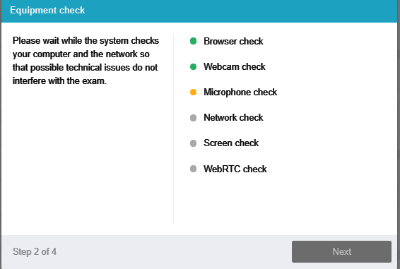
There are the following stages of verification:
At the stage of checking browser compatibility, it is checked that your browser meets the minimum requirements of the proctoring system. Make sure the browser window is maximized to full screen.
At the stage of checking the webcam, you need to give access to the camera in the browser if such a request appears. If the camera is working correctly, then the check will be successful.
At the stage of checking the microphone, you need to give access to the microphone in the browser if such a request appears. If the microphone volume is set high enough, the test will be successful.
At the screen verification stage, the correctness of the screen capture is checked, where you need to give access to the entire screen. If access is not given to the entire screen or an additional monitor is connected, then the check will be completed with an error.

At the stage of checking the connection, the possibility of transmitting video traffic in your network using WebRTC technology is checked. The check will be successful if the traffic is not blocked.
- Face photo
The proctoring system will require a photograph of your face to be taken through your webcam. A photograph of your face is part of the procedure for verifying your identity.

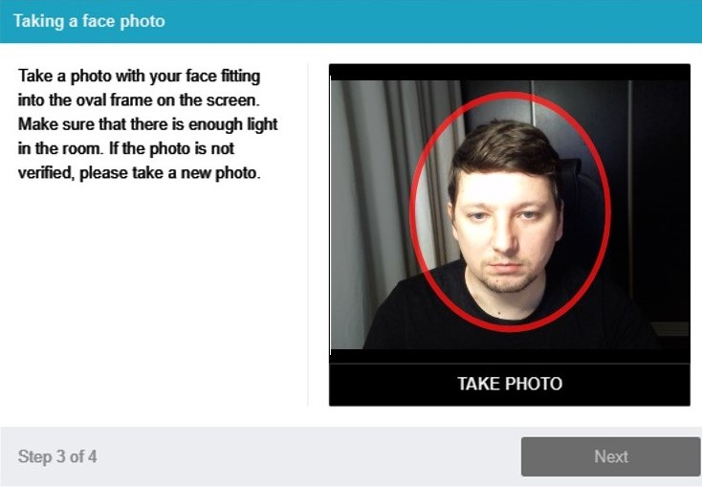

- Photo of the document
The proctoring system will need a photo of your identity document (ID card/passport), which needs to be taken via a webcam. The passport is automatically checked by the proctoring system for correctness and readability, and the photo in the passport is checked against your face. Photo of the document is part of the procedure for verifying your identity

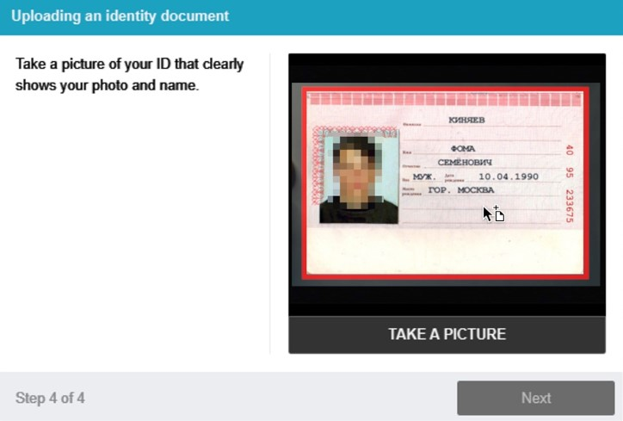
6.1 Camera position adjustment.
WEB camera position.
The participant's profile must be located exactly in the center and touch the upper border of the camera capture area. Arms up to the elbow should be visible.
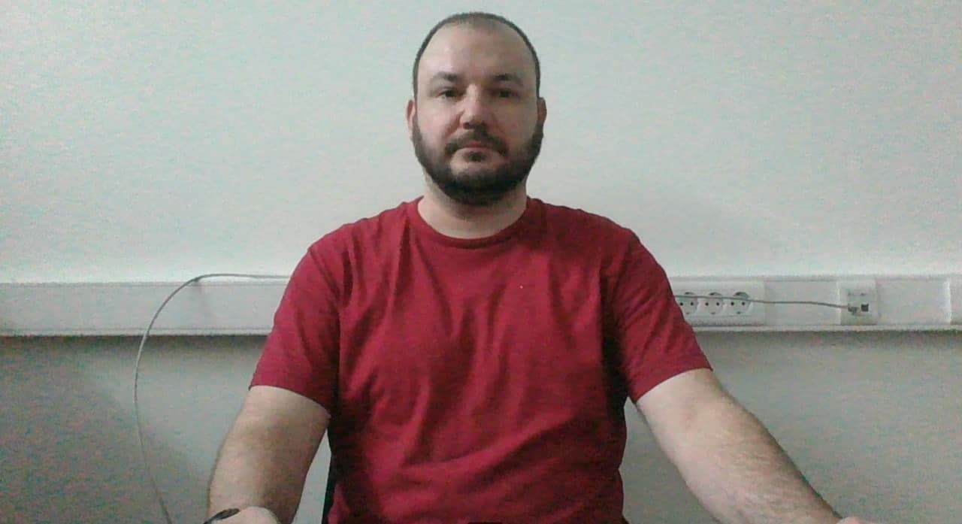
- Passing the exam
After successfully completing the previous steps, the exam page will open. The exam (test) page opens in the central part of the window, and a small circle is displayed in the lower left corner, where a picture from your camera is displayed. During the session, you can communicate with the proctor, if he is online, the chat with the proctor opens on the right side of the screen. Sometimes the proctor can connect via video and audio, in which case a video from the proctor's camera appears above the chat.
During the exam, make sure that your face fits completely in the circle and is well lit. Notifications may appear next to the circle if some exam rules are not followed. To start the exam, you must click the "Start Testing" button

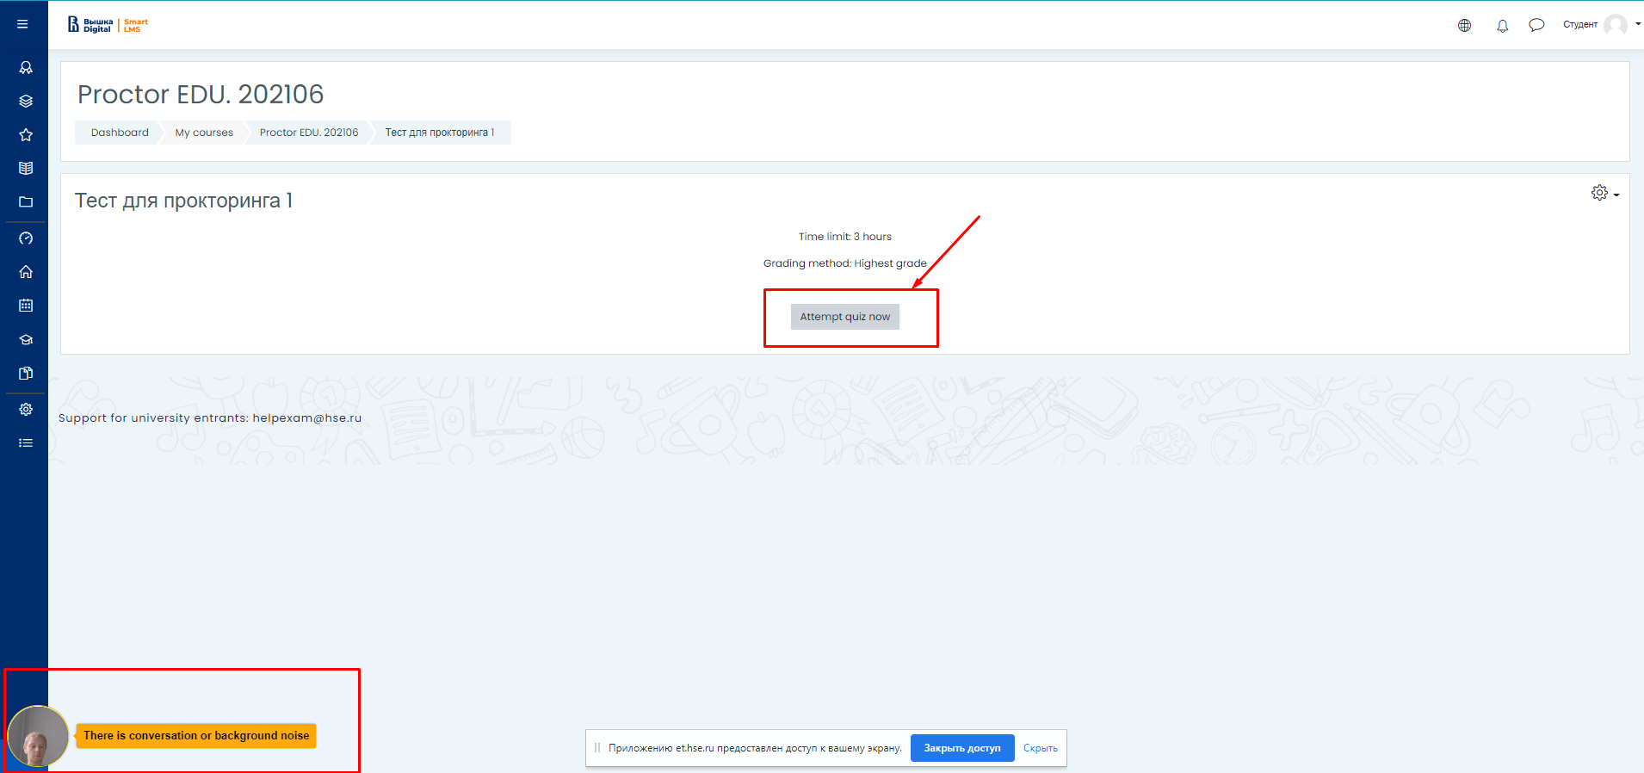
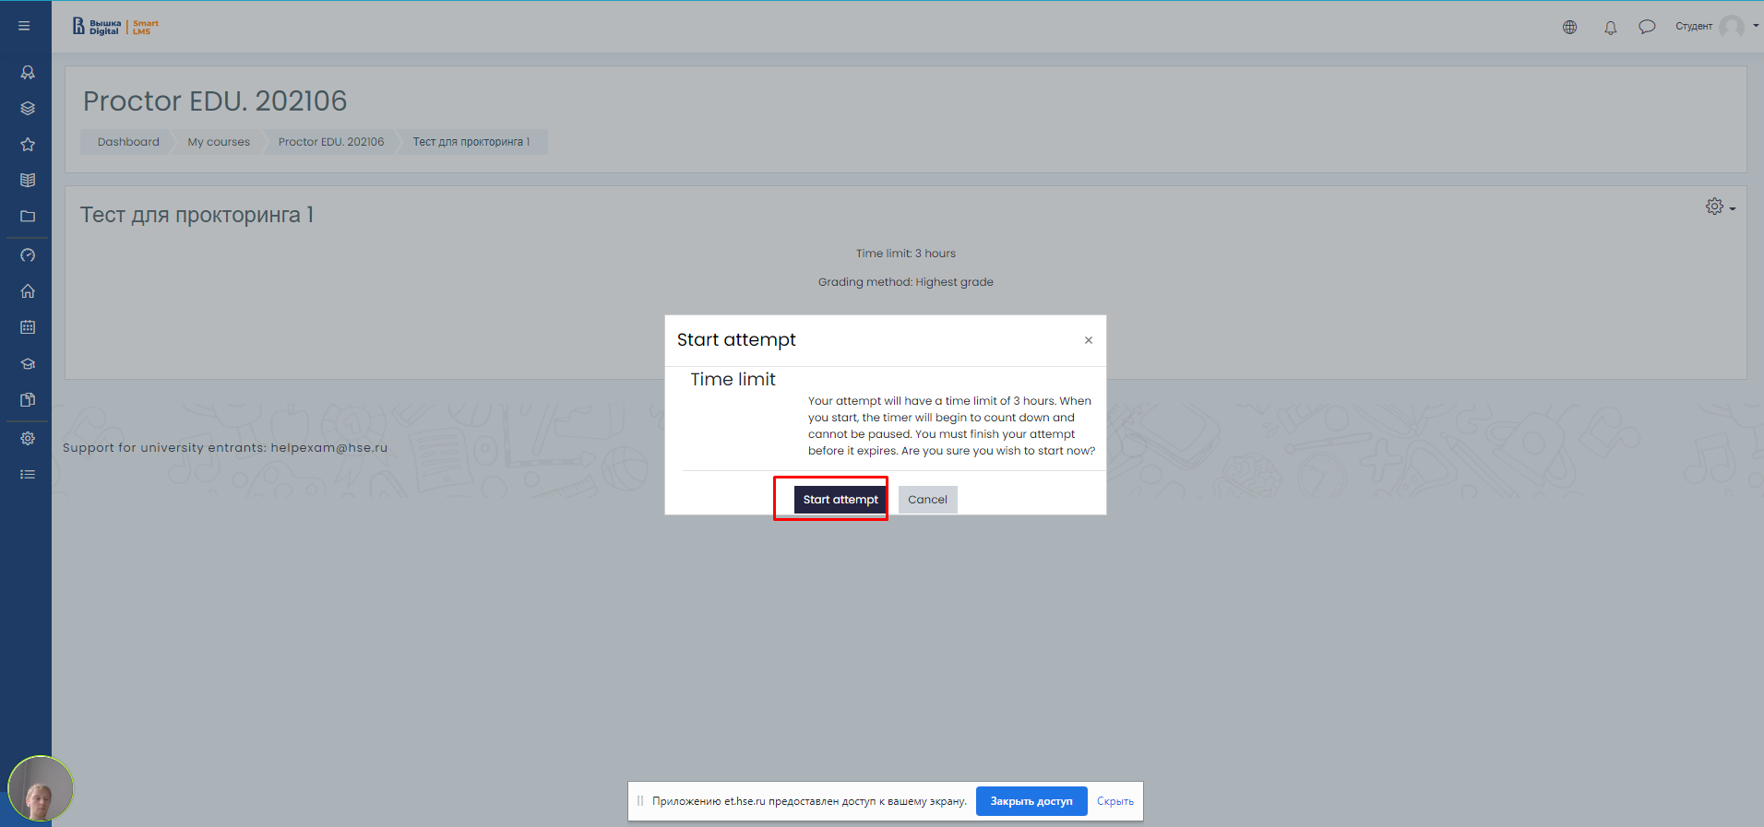
- After starting the exam, follow the steps outlined in the exam. The time until the end of the exam is shown in the right window
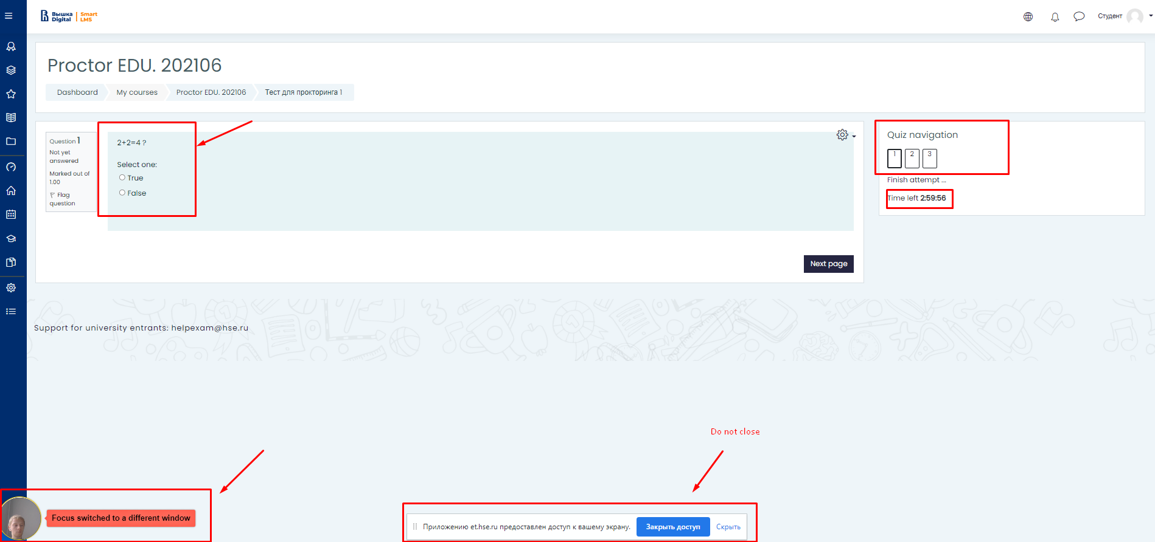

- End of the exam
Having accomplished all the assignments provided, finish the exam. To do this, click the "End attempt" button
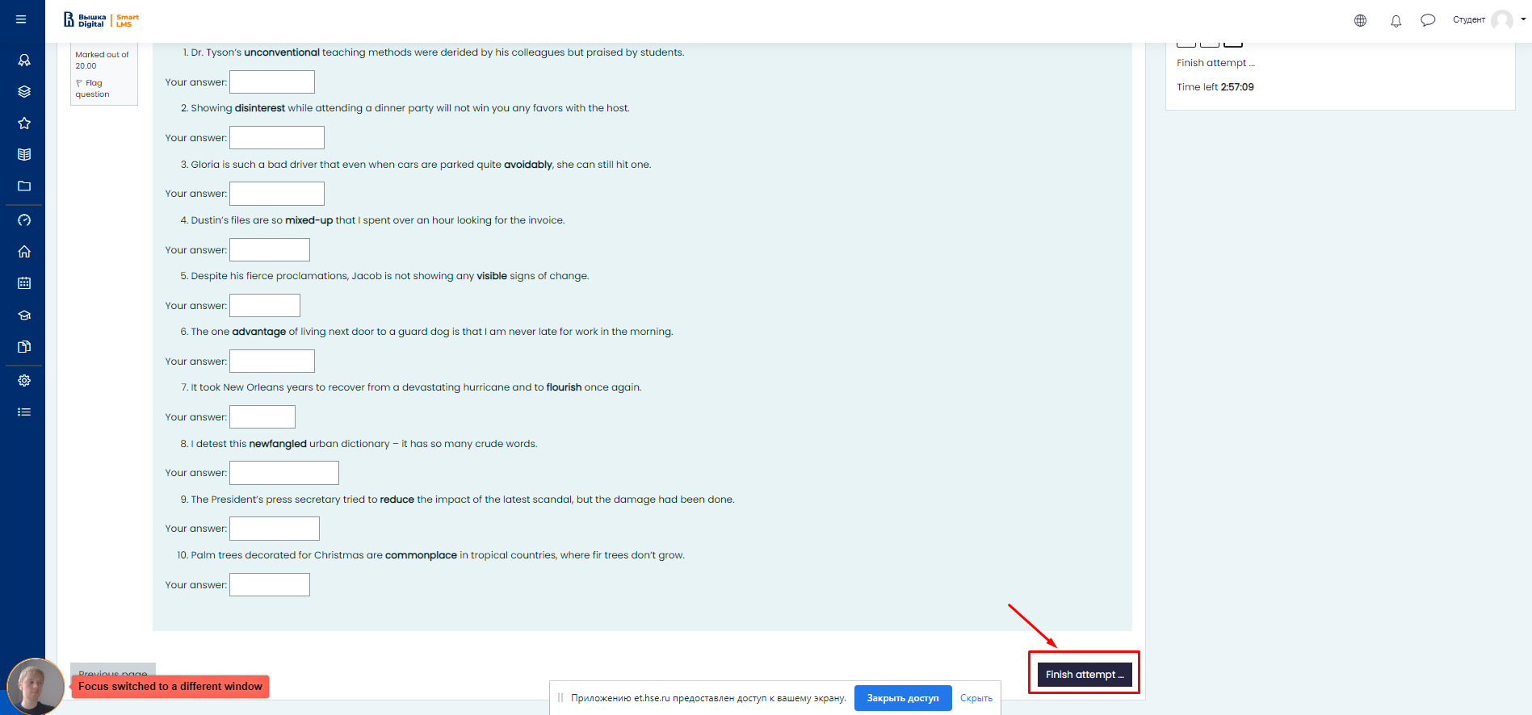

- After pressing this button, the system will ask you if you really want to complete the attempt, after confirmation you will not be able to start it again.

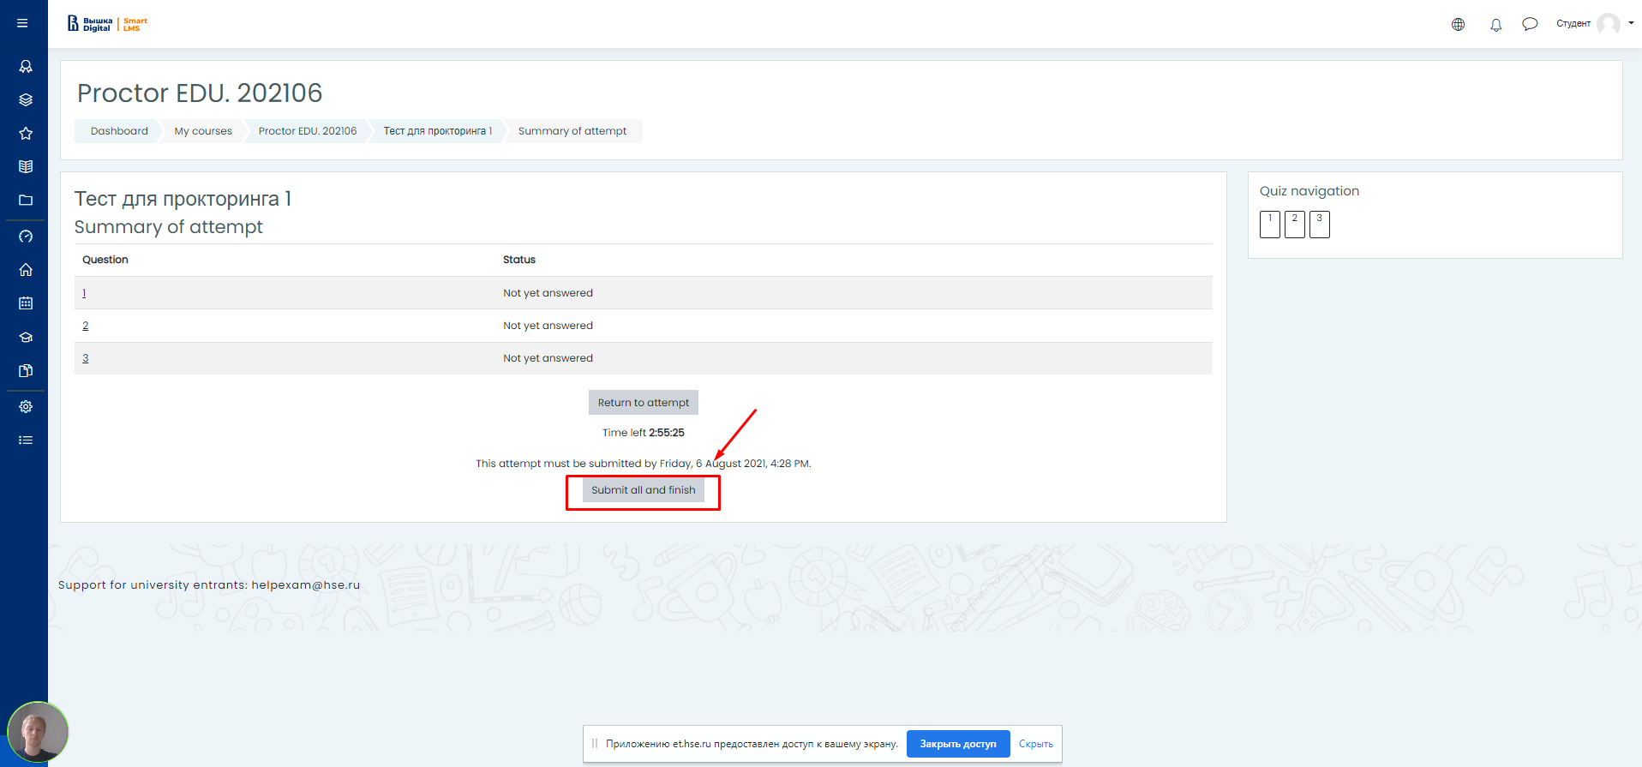

- In case of violations of the rules for passing the exam, the proctor has the right to interrupt the session, the examination stops, and its results are canceled. Also, completion occurs automatically after the end of the time allotted for the exam.
All audio, video and text messages, as well as recorded violations are saved in the system and linked to the proctoring protocol. After a while, the results are checked and a final conclusion on proctoring is issued, which is transferred to the selection committee.

IMPORTANT!

What not to do

Please note that the list of violations in the proctoring exam is the same as in the full-time exam: you cannot be late, walk, communicate with a neighbor or make noise, cheat, use prepared materials, search for answers on the Internet. A complete list of violations is specified in the Exam Instructions and Rules.

What to do, if:

— Didn't receive an email with a login/username and password to log in to et.hse?

— Login data should go to the email that you indicated on the PC. If you did not find the letter in the "Inbox" folder, then check the "Spam" folder or write to the technical support service at helpexam@hse.ru

— Before the exam the computer fails the test and "everything is broken!"

— Quickly write to helpexam@hse.ru, in the subject line indicating the surname, faculty name, exam title and briefly describe the problem

— There was a technical glitch during the exam

Quickly write to helpexam@hse.ru, indicating the surname, faculty name, exam title in the subject line and briefly describe the problem

Questions and answers for applicants

— Why show your passport?

— For an online exam, the progress of your exam can be monitored by HSE staff from outside your department or external proctors, so personal identification is required.

In the course of proctoring, NRU HSE checks the identity of a test taker by comparing the person in the session room and the original passport or other identity document submitted by him.

— What happens if an extraneous noise starts during the exam (the cat meows, the neighbors are making repairs)? Will the exam stop? Will some kind of warning window appear? Will there be a difference between alerts for synchronous and asynchronous proctoring?

—
If there is a lot of noise during the exam, the proctor or proctoring system will flag it as a violation, but the exam will not be terminated.

In synchronous proctoring, the exam is supervised by a proctor, a specially trained person. The task of the proctor is not to "overwhelm" the applicant, but to control the course of the exam, and to guarantee the reliability of the assessment procedure itself. During synchronous proctoring, the applicant has the opportunity to ask a question to the proctor (not according to the content of the exam) in the chat for communication.

Most often, the proctor is asked how much time is left until the end of the exam and what should be done if the exam is finished ahead of schedule.

In case of serious violations (the applicant gets up from his seat, opens different tabs on the computer, speaks out loud, communicates with strangers, gets help with solving the task from another person, uses pre-prepared notes, gadgets, ignores the comments of the proctor), the proctor will mark these actions as violations and send the alert to the chat with the applicant. In case of several serious violations, if the applicant does not respond to comments, the proctor may mark the exam as unreliable.

The final decision will be made by the management of the educational program. The video of all exams in which violations were recorded will be additionally analyzed by the University staff, and the confirmed violations will be recorded in the report.

With asynchronous proctoring, the system will automatically record the course of the exam, while the applicant will still receive automatic warnings about the violations recorded. After the exam, the HSE employee will be able to watch the video of the exam and confirm / deny a possible violation. The employee who checks the videos knows the rules for conducting the exam (which could be used in the process of passing: drafts, reference materials in paper and electronic form, calculators).

All non-standard situations that the applicant cannot influence are considered from the point of view of common sense and a rational approach (the applicant dropped a handle - he bent to pick it up, a cat jumped on the table, a child suddenly started crying in the next room, the doorbell rang, etc.)

An analogue of control in this situation is the anti-plagiarism system. When uploading a work, anti-plagiarism may show a high percentage of anti-plagiarism in a self-performed work, but this is not a confirmed fact of cheating, the decision is made after additional verification and confirmation.

— Can I take my eyes off my computer screen when doing writing assignments? How it threatens in asynchronous proctoring?

—Yes, you can.. It is worth worrying for those applicants who, throughout the exam, regularly look away from the examination task at various objects in order to cheat.

— How do I know if my exam is under asynchronous proctoring? When will I know if the proctors have questions for me?

— The type of proctoring synchronous / asynchronous is reflected in the LMS. The exam rules are posted on the PC page for review. If the proctors have any questions for you, they will indicate them in the chat.

